Sean Tveter

10/16/2022

IT FDN 100 B

Assignment 5

# Knowledge Document 05

# Introduction

For this module, I had much more success in understanding what the assignment was asking. Going into last week, I felt like there was a large jump up in difficult and I struggled to grasp what I was trying to accomplish. After going to class this week and spending more time practicing, I found this assignment to be much more manageable. To start off with I did all of the readings and took more in depth notes than usual, which helped me to find some of the questions that I ran into. Finally, I found that separating the code into smaller chunks helped me to better analyze and find mistakes in my code. I think this week I took a big step forward, and I learned a lot!

# Assignment

To start my assignment, I practiced several examples in my book that went over how to create dictionaries, how to add to them, and how to delete things from them. After practicing, I started with my pseudocode for this assignment. After updating the pseudocode, I set my dictionary. The dictionary is filled with some of my favorite songs, organized by song name, ID number, and artist. This is the dictionary that I used to perform all the actions of this assignment.

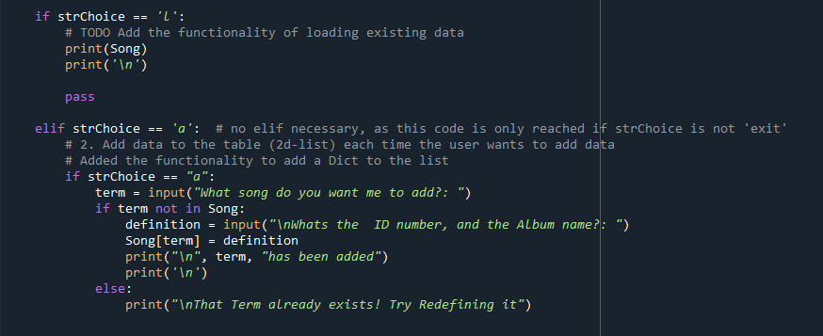

Next up, I wrote the middle section of the code. After writing the ‘quit’ section, I wrote the first section that was difficult. To add new songs, I used a similar code as to what we used last week and integrated several pieces from examples in the book, allowing me to create a working section of code.

Finally, I worked on the end section of my code. The most difficult section of code in this picture was the deleting functionality. By using several examples from the book, I was able to piece it together after some trial and error in a new file. And the last section, I used my last week’s code to open a txt file, print the Song dictionary, and the finally close the file.

# Conclusion

For the final part of assignment, we uploaded our code to github.com and performed a peer review on another person’s assignment. This was an interesting aspect to include in our assignments. It showed me that there are so many different ways to complete an assignment, even if we all start with the same code. To finish with my assignment, I am very happy with the way I completed this assignment, and I am excited to continue learning about coding in this course.